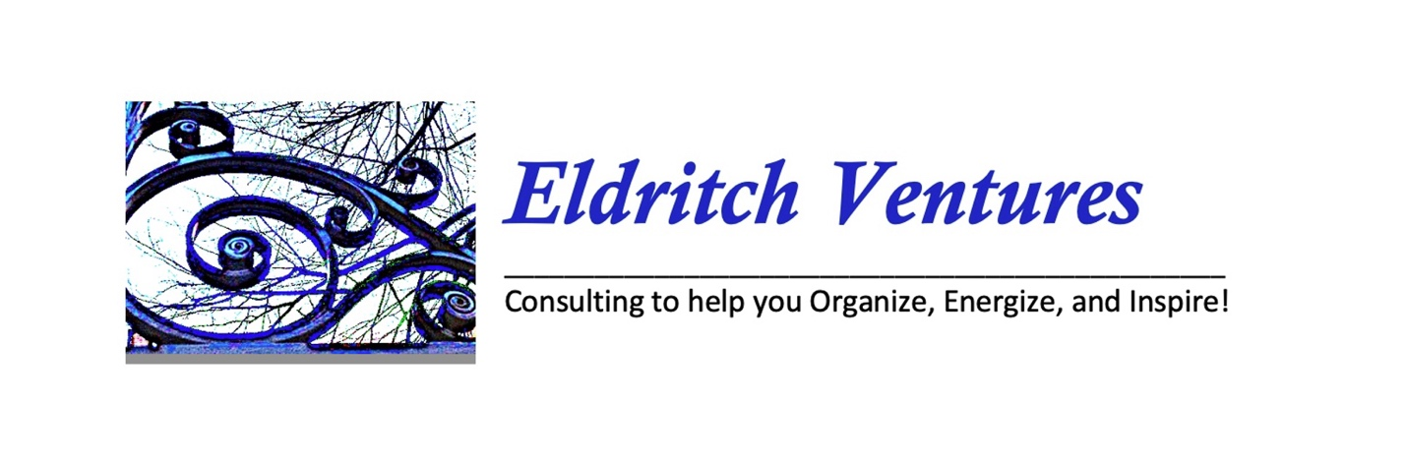

Organize | Energize | Inspire | Thought of the Day
Image | Image | Image | Image
Events  Classes | Themes  Brainstorming | Art  Music  Stagecraft | Featured Project

Contact Me: Service:
Ideas to help accentuate your events and projects
Ideas to jump start and promote your activities
Rights — Information and Referral for Social Justice
Rites – handfasting, name claiming; and milestone events

======================== Calendar Page =====================
Note: This is a single-text based page with links to “one pager” event description/history PDF that I will make to build and post an ongoing portfolio of my work)

Eldritch Ventures Engagement Calendar and Portfolio
EV 2023 | EV 2024 | EV 2025
Creating Change 2023  Red Dragon 2023  Sacred Space Conference 2023  SCW Spring Gathering 2023  Pagan Spirit Gathering 2023  Pagan Leadership Institute 2023  Frederick Pagan Pride 2023  SCW Fall Gathering 2023  Transgender Day of Resilience 2023 | Creating Change 2024  Red Dragon 2024  Sacred Space Conference 2024  SCW Spring Gathering 2024  Pagan Spirit Gathering 2024  Pagan Leadership Institute 2024  Frederick Pagan Pride 2024  SCW Fall Gathering 2024  Transgender Day of Resilience 2024 | Creating Change 2025  Red Dragon 2025  Sacred Space Conference 2025  SCW Spring Gathering 2025  Pagan Spirit Gathering 2025  Pagan Leadership Institute 2025  Frederick Pagan Pride 2025  SCW Fall Gathering 2025  Transgender Day of Resilience 2025
EV 2023 | EV 2024 | EV 2025
Pride Interfaith Service Planning  43rd Pride Interfaith Service  Parliament of the World’s Religions | Pride Interfaith Service Planning  44th Pride Interfaith Service  Artomatic 2024 | Pride Interfaith Service Planning  45th Pride Interfaith Service  World Pride 2025

========================= Organize (Blog-Like Posts) ==========================================

Organize Events
Interfaith – Creating Change 2024 I am on the team for Practice Spirit, Do Justice that coordinates the annual Faith Institute and the annual Interfaith Service. https://www.thetaskforce.org/creating-change/
Leave a comment:

Interfaith – DC Pride Interfaith Service now in its 44th Year I am in my 25th year of co-coordinating this legacy project, and passing on leadership to the next generation.

https://thedccenter.org/centerfaith/
Leave a comment:

Interfaith- Pride Interfaith Service Toolkit – Help us imagine and realize dream that each city that hosts a Pride Parade and a Pride Festival also hosts a Pride Interfaith Service. We can do this! Watch this space for a link to a Pride Interfaith Toolkit to help you build a service (small or large) in your hometown!
<Toolkit Link Coming Soon>
Leave a comment:

Interfaith – Parliament of the World’s Religions The program at the 2023 Parliament of the World’s Religions brings together faith and religious leaders, academic and industry experts, and institutions and grassroots organizers committed to interfaith dialogue and action. I attend this conference with a delegation of Pagans from Circle Sanctuary.
https://parliamentofreligions.org/our-work/mission/

Leave a comment:

Organize Classes

The Sacred Fool – Roles and Responsibilities of a Radicalized Spiritual Practice - The Sacred Fool explores The Fool of the tarot, the goddess Baubo of the Eleusian Mysteries and the daring figure of the Court Jester. The job description of the Fool is speaking truth to power; liberating the oppressed; mediating divergent points of view; shifting paradigms; creating synchronicity in chaos; combining the incompatible; the profound and the profane.
Leave a comment:

Techno Pagan Shareshop (PLI) - While modern-age technology rapidly changes lives people continue to find center and live as primal beings. The ancient world dreamt of the eons past and the modern age to come while today’s world reaches ahead and reaches back in time for meaning. This seminar asks you an essential question: Where do you stand in time? Where do you find inspiration for living your life today? We’ll explore the paradox of primal spirituality in a modern technological world.
Leave a comment:

Drawing on Spirit (PLI) - Practice a meditative technique for drawing on paper and drawing on spirit to create meaningful mandalas of insight and power. Everyone can doodle. Everyone can color. Everyone can relate to a symbol and lines set on paper. Based on the principles of Source Imagery (Schuman) discover the principles of juxtaposition of color line symbol. Take a break from lecture learning to practice a delightful form of spiritual exploration. Non-artists are encouraged to attend.
Leave a comment:

========================= Energize (Blog-Like Posts) ==========================================

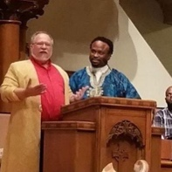
Leading Inter-Religious Ceremony Consult with me to learn principles and effective practices for leading ceremonies in inter-religious gatherings. Learn methods for producing events with clear goals, energetic presentations and effective representation of religious pluralism. Discussion emphasizes the importance of Pagans as community representatives in collaboration with clergy and lay leaders.
Leave a comment:

Creating Community Events - Consult with me to learn methods of creating compelling programming that delivers your message, weaves connection and builds energy for continued community involvement. Build a singular event with impact or design a series of events that can repeat annual and grow a legacy. Write your own stories or retell tales with a wide newly tapped talent in your organization, ask me about the Faerie High Tea, The Snow Queen or Red Dragon.
Leave a comment:
‘

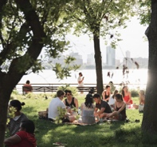
Activities that Raise Energy and Raise Funds – Local and regional community groups can pool resources and pull together to raise energy and funds for worthy causes. Within each community are hidden talents and untold ideas that draw from the values and good will to create auctions, fashion unique crafts or offer themed picnics featuring local recipes.

Leave a comment:

========================= Inspire (Blog-Like Posts) ==========================================

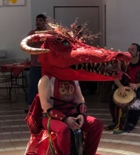
Stagecraft – Consult with me on creating or co-creating stage pieces for community theater advertising, promotion that inspire. With years of experience in art, design and craft making your ideas can become focus pieces that draw attention, focus intention and inspire generations. Stage pieces speak to the hearts and minds with artful and moving symbology that reaches deep for rituals and events.

Leave a comment:

Making Music – Everyone can create music that stirs the soul and spirit of a group. Consult with me on creating or co-creating lyrics, music for ritual chants, drum circle sing-along songs and commemorations of special events. I can assist individuals who are not musically inclined and collaborate with individuals who are musically inclined to fashion words, melodies and rhythms for celebrations and memorials.
Leave a comment:

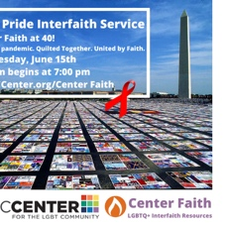
Designing Promotional Art – Effective messaging is key for creating moments and building movements. Consult with me to find images within your community that speak within a group or broadcast messages from a group to world to communicate ideas and values for a better world.

Leave a comment:

========================= Thought of the Day (Blog-Like Posts) =============================

What in the World – Thought of the Day

Leave a comment:

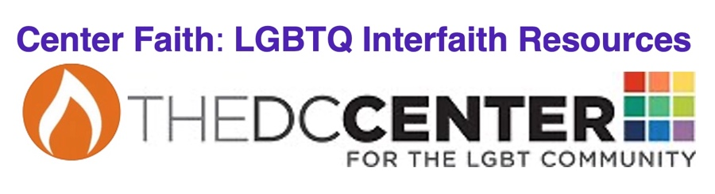

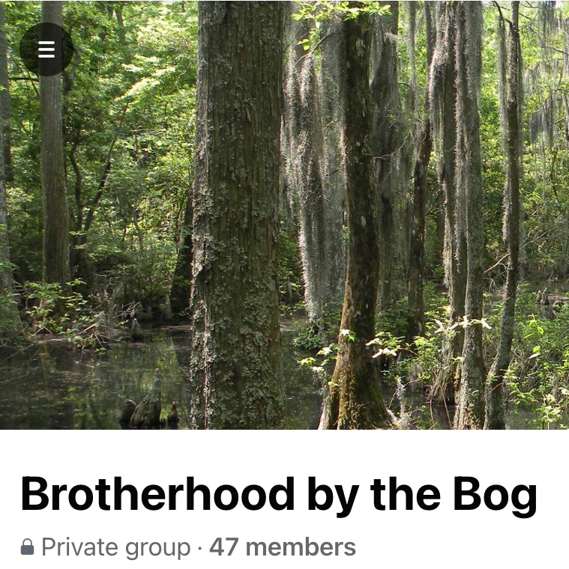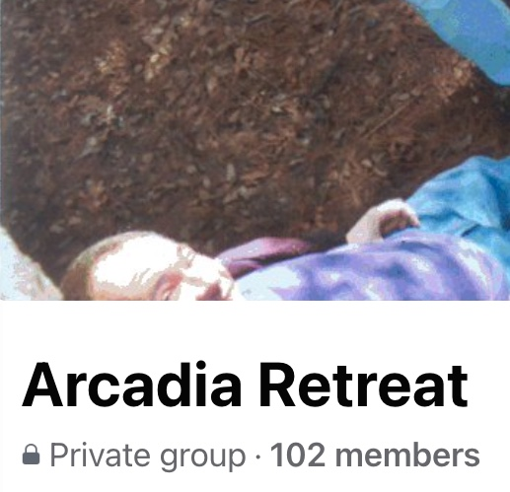

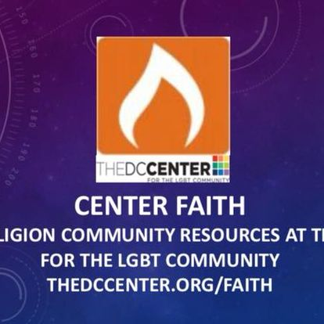

Calendar option … draft version for thinking outloud

EV 2023 | EV 2024 | EV 2025
January  February  March  April  May  June  July  August  September  October  November  December | January  February  March  April  May  June  July  August  September  October  November  December | January  February  March  April  May  June  July  August  September  October  November  December
Events  Classes | Themes  Brainstorming | Art  Music  Stagecraft

EE Hold Text: ARTOMATIC Artomatic is back for 2024! March 9 to April 28, Wednesdays through Sundays at 2100 M Street in the West End. Two DJ stages, at least one film space, a small theatre (for plays and readings), and a dance stage/open performance space. Want to see the space? Join the ARTOMATIC mailing list and join the next tour!

